**Wind Tunnel I –Pre Lab**

**Objectives:**

**List contributor with date and time! 8:10 pm 2/4/15 Sabatino**

Explore how aerodynamic forces effect different bodies when exposed to various flows, using a wind tunnel.

**“affect” not “effect”. Much too vague. Provide motivation then more specifics about what specific phenomenon you are trying to study . 8:10 pm 2/4/15 Sabatino**

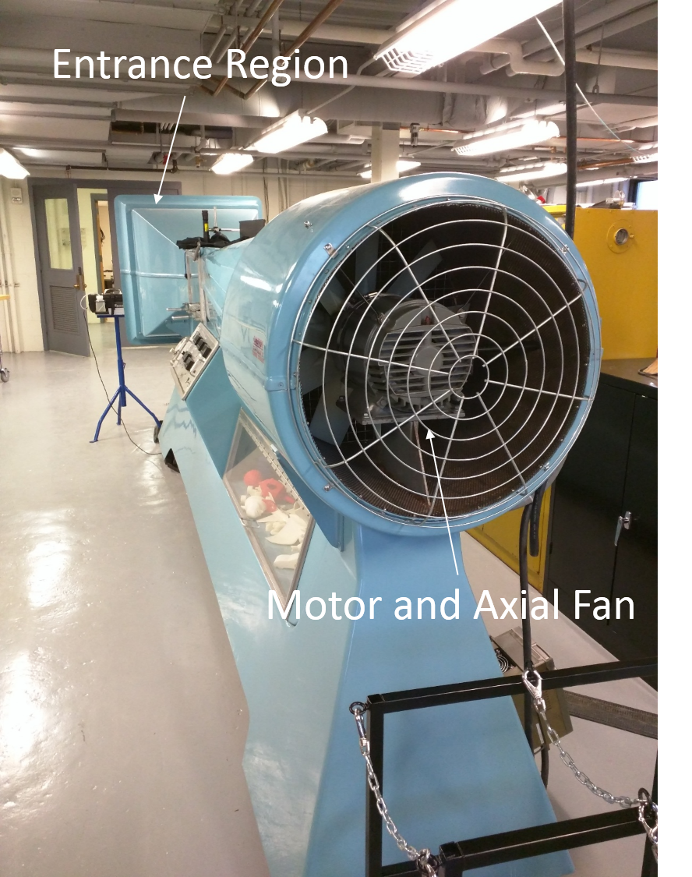**Apparatus:**

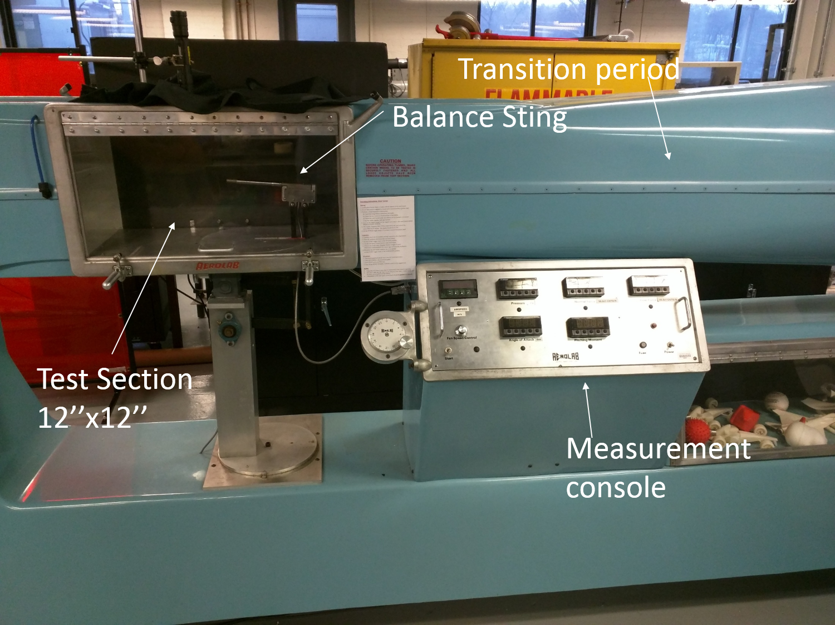

**Good 8:10 pm 2/4/15 Sabatino**

**Procedure:**

Collecting data for the 3 spheres (1.5”, 3”, 4”)

1. Make sure that the wind tunnel is not currently operating
2. Adjust the sting balance fixture so that the sting balance fixture is at a zero angle of attack
3. Secure the first sphere to the sting balance fixture.
4. Close and secure the viewing window.
5. Make sure that the entrance and exit grates are clear of obstructions and people.
6. Collect data for the axial force on the sphere over the complete range of air speeds.

**Which speeds and why. Be specific. What behavior are you looking to capture. How will you know you have recorded it? 8:10 pm 2/4/15 Sabatino**

1. Using Reynolds number correlations for a sphere, along with the equation for smooth sphere drag coefficient (Eq1 appendix) to make a Cd vs Re table for collected data that will be compared to data from published values.
2. Repeat these steps (1-6) for the remaining 2 spheres.
3. Collect airspeed and axial force data for the 4” sphere with a turbulent trip and a standard golf ball
4. Observing safety protocol listed above (steps 1-5), attach a Clark-Y airfoil model to the sting balance.
5. Adjust the angle of attack for the sting balance to -6 degrees
6. Set the airflow velocity of the wind tunnel to 40m/s
7. Measure and record the axial and normal forces for the airfoil at this angle of attack
8. Vary the angle of attack from -6 to +20 degrees in 2 degree increments and record the axial and normal forces for each of these angles of attack.
9. Using the documentation and equations provided for 3-D lift theory to calculate the coefficient of both lift and drag as functions of angle of attack and plot them. Compare to published values.
10. Make sure that the laser apparatus for flow visualization is situated correctly for use.
11. Emit CO2 into the entrance of the wind tunnel and observe the flow over the airfoil in order to visualize the flow.

**Fog, not C02. We actually talked about this at length in lecture** **8:10 pm 2/4/15 Sabatino**

**Do you need to calibrate the sting balance? How does it just measure aerodynamic forces? What is the goal.. you measure and compare to published values to what end? What are you looking for in the flow viz? 8:10 pm 2/4/15 Sabatino**

**Relevant theory:**

The forces that the body within the wind tunnel will experience will be lift force and drag force. These must be understood in order to test their effect on the body.

Drag force flows along the body in the direction of the wind and comes in two forms, viscous and pressure drag. Viscous drag forms when fluid in the viscous layer running over the body creates shear stresses on the body; these will only appear where there is a momentum boundary layer adjacent to the body. The pressure drag comes from the pressure of the fluid on the surface of the body and the boundary layer of the fluid separating from the body.

Lift Force is perpendicular to the solid and is also a result of pressure on the body from the fluid. If this force is not balanced by the perpendicular drag forces, the object will be lifted.

In order to identify drag and lift forces (FD and FL) respectively there are equations that relate the experiment parameters. From previously defined theory we can set the equations for lift and drag forces as:

$F_{D}= F_{N}\sin\left(α\right)+ F_{A}cos⁡(α)$

$F_{L}= F_{N}\cos\left(α\right)-F_{A}\sin\left(α\right)$

Where FN is the normal force, and FA is the axial force applied to the experimental geometry. The angle of attack is denoted by, α, and dictates the orientation of the object, with respect to horizon. The angle of attack has a large influence over the lift and drag forces. At extreme angles of attack stall is known to occur, this is where the drag forces overpower lift forces. In practical terms, when an aerial object stalls, it will fall from the sky.

To put lift and drag forces into context, they are often displayed as non-dimensional coefficients (cL and cD) this is found from the following equations:

$c_{L}=\frac{F_{L}}{\frac{1}{2}ρV^{2}A}$ and $c_{D}=\frac{F_{D}}{\frac{1}{2}ρV^{2}A}$

Where FL,D are the magnitude of the lift or drag forces, over the kinetic energy of the forced flow, and the area is frontal area or the planform area, dependent on which coefficient is being found.

Cross-sectional areas of objects that are specifically designed to create lift are called airfoils, like the asymmetrical shape of plane wings. Airfoils create lift by creating a circulation of air that pushes the wing up as it flows by the wing. The front of the airfoil facing the flow is called the leading edge, and contains the largest curvature. The airfoil then tapers down to the trailing edge, which also will have a very high curvature.

The upper section of an airfoil is designed to allow the flow to pass by a high velocity with low pressure on the wing, while the lower surface has slower fluid that creates a pressure differential between the top and the bottom, therefore creating lift.

While the flow over an airfoil is 3D, to create a reasonable experiment, the airfoil will be treated as 2D; only the forces in the axial and normal to the flow will be investigated. This is possible by assuming that the aspect ratio of the wing is infinite. Once the data is collected, a correction factor will can be applied to adjust for the infinite AR.

**Ok. This is basically the handout. How will you measure velocity? How will you use the data and correlation for the sphere? What is the relevant lifting line theory. What phenomenon are you investigating? What are the relevant physics? 8:10 pm 2/4/15 Sabatino**

Possible Sources of Error

While testing particular geometries there are inherent limitations to simplified theory and the test apparatus. For theory there are several assumptions meant to simplify fluid dynamic calculations that may adversely affect our collected results. The simplification of a three dimensional object to an infinitely long 2D shape will provide error, as well as the assumption of incompressible flow. Finding the correct Reynolds number will be a challenge assuming static air density. It is assumed that the wind tunnel is calibrated properly. One of which is ignoring flow vortices that occur from flow over an edged shape, for the airfoil testing this will have a definite effect on the observed measurements

**Data Table:**

**Insert links to files and use standard naming convention:**

**<group >_<lab name>_v<version number>**

|  |
| --- |
| [**B3_WindTunnel_Matlab_V1.m**](B3_WindTunnel_Matlab_V1.m) |
| **Revision Number: V1** |
| **Revision Comments:** |

**Matlab is a very good start. What about comparisons to pub data though so you can decide quality as you take data? 8:10 pm 2/4/15 Sabatino**

**Roles and Responsibilities:**

Kevin: Objective, Relevant Theory

David: Procedures

Sam: Matlab

Jorge: Apparatus

Justin: Relevant Theory

Chris: Procedures

**Wind Tunnel I – Lab Observations**

**Create a new version of your data file if it was changed following the pre-lab.**

**Where is your EXCEL sheet? How will capture uncertainty?**

**8:10 pm 2/4/15 Sabatino**

|  |
| --- |
| **A4_WindTunnel_Data_v2.xlsx** |
| **Revision Number:** |
| **Revision Comments:** |

**Insert relevant pictures (or links if media file is large). This is expected to unedited media with initial observations. Not everything included in this section will be seen in the report, but it is critical to record as much as you can as it is difficult to know what will turn out to be most important to your interpretation of the data.**

**Wind Tunnel I – Post Lab**

**Analysis approach described here.**

IMPORTANT! DO NOT BEGIN MATLAB FILE NAMES WITH A NUMBER! MATLAB WILL RETURN A CRYPTIC ERROR

|  |
| --- |
| **A4_WindTunnel_Analysis_m.xlsx** |
| **Revision Number:** |
| **Revision Comments:** |

**Roles and Responsibilities:**

**Identify the primary contribution of the team members during the post-lab.**